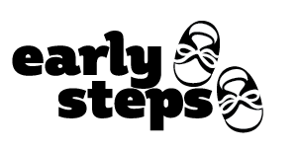

Notification Opt-Out Form
Child’s Name: ____________________________________
Child’s Date of Birth: ______________________________
The Local Early Steps (LES) is required to send notification information which includes the child’s name, date of birth, parent(s) name, and parent(s) contact information to the Department of Education (DOE) and the local school district in which the child resides.
I object in writing to having the LES share my child’s name, date of birth, my name, and contact information to the DOE and local school district in which I reside. I understand that if I do not sign below, this notification information will be shared.

_________________________________
Signature of Parent or Guardian

_________________________________
Print Name

_________________________________
Date

