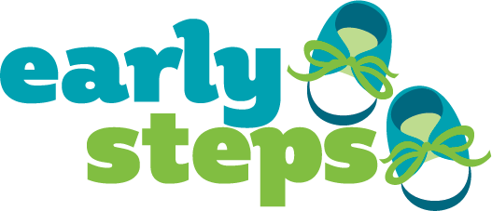
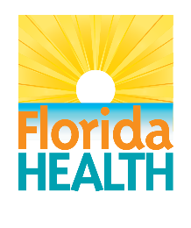

Local Early Steps (LES) Office
Public Awareness Material Approval Request
Materials must be included with submitted request.
Please submit requests at least 3-5 weeks prior to anticipated implementation.

Request Date: Enter date.
LES Region: Choose a region.

- What are the key messages and goals of the public awareness material(s)?

- Who is the target audience?

- How will the materials be distributed?

- Are the materials a revision to ones currently being used by the service area?
(If yes, please attach material currently being used) Why are the materials being revised?

- Do the materials use plain, easy-to-understand language?

- If families are featured, have the required consent forms been completed by all?
☐ Yes ☐ No

Please make sure the material contains the required sponsorship statement (indicated in italics below) a contact number, and the FloridaEarlySteps.com website address.
Sponsored by (provider name) and the State of Florida, Department of Health, Children’s Medical Services.

(Information below this line to be filled in by the Early Steps State Office)
Please add feedback/comments here
Date of review: Enter date. Date memo e-mailed to LES: Enter date.

