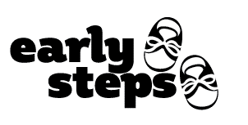

**Department of Education (DOE) and Local School District**

**Notification Opt-Out Form**

Notification is the process of informing the DOE and school districts that a child living in their district is receiving Early Steps services and may be eligible for preschool education services. Early Steps (Part C) and preschool education services (Part B) are both parts of the Individuals with Disabilities Education Act (IDEA), and notification is required under the IDEA. Notification allows the school district to plan for children who may need preschool special education at age three. Consent is not required to send notification information, though Florida allows parents and caregivers to opt-out of having the Local Early Steps (LES) disclose notification information.

Notification information includes the child’s name, date of birth, their parent/caregiver(s) name(s), and parent/caregiver(s) contact information. Additional information, such as evaluation/screening information and the Individualized Family Support Plan (IFSP), is shared with existing consent provided on the Release of Confidential Information and Consent to Bill form.

I object to having the LES share my child’s name, date of birth, my name, and my contact information, and revoke consent to provide confidential information to the DOE and local school district in which I reside. I understand that by signing below, I am opting out of notification, and my information will not be shared. I also understand that this does not revoke consent to referrals to other community programs.

|  |  |  |
| --- | --- | --- |
|  |  |  |
| Child’s Name |  | Child’s Date of Birth |
|  |  |  |
|  |  |  |
| Parent/Legal Guardian’s Name |  | Parent/Legal Guardian’s Signature |
|  |  |  |
|  |  |  |
|  |  | Signature Date |